Expertise consolidated: voxeljet, Fraunhofer IPA and University of Bayreuth accelerate development and qualification of new polymer materials for HSS

HSS Material Network realizes "Proof of Concepts" for HDPE and iglidur® i3 PL

Friedberg, 7 November 2022. The HSS Material Network, launched in September 2021, has recorded its first successes in the field of High Speed Sintering (HSS) contract research. The network partners voxeljet AG (NASDAQ:VJET), Fraunhofer IPA and the University of Bayreuth have been working on qualifying pioneering materials for the additive manufacturing of polymer parts in HSS, including HDPE (high density polyethylene) and iglidur® i3 PL. The cooperation within the HSS Material Network aims at the accelerated development and qualification of new polymer materials for the HSS technology and offers material manufacturers, as well as service providers, the option of cost-effective qualification. In order to steadily increase the portfolio of tested materials for the HSS and along with it the know-how, interested companies are welcome to join the network.

Companies often lack access to process-specific know-how, the equipment and the interdisciplinary skills and resources to conduct their own materials research and technology optimization. The HSS Material Network closes this gap. It offers companies a flexible and low-risk outsourcing option to identify the best material for their additively manufactured application, including the appropriate process parameters. "With the bundled competence and expertise in our network, we can provide companies of all sizes with optimal support for their additive manufacturing projects. Starting with an initial suitability test, through specific development and parameterization, to certification or market-ready qualification of the material," says Tobias Grün, Product Manager at voxeljet.

The Campus Additive.Innovations (CA.I) of the University of Bayreuth, in which the Fraunhofer Institute for Manufacturing, Engineering and Automation IPA is also involved is an inter- and transdisciplinary think tank and operates within the HSS Material Network. The CA.I, has more than 20 different additive manufacturing systems, including a VX200 HSS from voxeljet. "All research systems in the CA.I have open software and hardware interfaces and enable individual setting of all process parameters, free programming of the process steps and high scalability. Such systems are ideal for coordinating the manufacturing process and material," says Jan Kemnitzer, group manager at Fraunhofer IPA. Through the cooperation and open exchange of the network partners, the HSS Material Network is able to effectively accelerate the development of new materials. Companies receive an application-oriented solution that is specifically tailored to their needs and quickly delivers initial results for potential qualification. Further benefits are the high flexibility in powder selection and options for scaling up for production applications of processable materials.

Successful proof of concept for the materials HDPE ...
After extensive research, the network has now achieved two significant "proofs of concepts" for the two materials HDPE and iglidur® i3 PL. The proof of concept for HDPE was made from the HDPE powder DiaPow HDPE HX 11, which Diamond Plastics GmbH developed for laser sintering. HDPE is a high-density polyethylene with water-repellent properties and very good resistance to chemicals and greases. It is used, for example, in the manufacture of products for the food and packaging industries. The process capability analysis and initial parameterization, carried out by the Process Innovation Project Group of Fraunhofer IPA and the Chair of Environmentally Sound Production Technology at the University of Bayreuth, demonstrate that the HDPE powder has very good processability in HSS. Processing HDPE via HSS offers several advantages over other additive manufacturing processes, such as laser-based process technologies, including lower thermal stresses on the material and preservation of the proven mechanical properties of HDPE. In addition, HDPE is a widely used commodity plastic that is much less expensive to manufacture than PA12 or PA11. Finally, manufacturing HDPE in Europe ensures secure supply chains and times.

... and iglidur® i3 PL
The second successful proof of concept refers to the iglidur® i3 material. The igus® GmbH has developed the plastic powder especially for the production of gliding applications and gears via the additive manufacturing processes of Powder Bed Fusion of Polymer (PBF-P), for example laser sintering (SLS). The special feature of iglidur® i3 PL is the additivation of the powder with solid lubricants. The parts manufactured from it exhibit a very high abrasion resistance and up to 30 times higher wear resistance than parts made of other commercially available plastic powders. The plain bearings and gears manufactured in HSS by the Fraunhofer Process Innovation Project Group of Fraunhofer IPA and the Chair of Environmentally Sound Production Technology at the University of Bayreuth as part of the proof of concept exhibit very good tribological and mechanical properties, which make further optimization of the polymer powder specifically for the HSS process and full qualification quite interesting. In addition, thanks to its open-source concept, HSS has the possibility to specifically adjust component properties on the process side.

In order to steadily increase the portfolio of tested materials for the HSS process and, along with it, the know-how, interested companies are welcome to join the network.

About the HSS Material Network
voxeljet AG, manufacturer of industrial 3D printers and provider of on-demand printing services, the Fraunhofer Institute for Manufacturing Engineering and Automation IPA, and the University of Bayreuth launched the HSS Material Network in September 2021. As part of the cooperation, the partners aim to accelerate the development and qualification of new polymer materials for high-speed sintering (HSS) technology. The network offers customers a flexible way to have new polymers tested, qualified and certified. In order to steadily increase the portfolio of tested materials for the HSS and, along with it, the know-how, interested companies are welcome to join the network.
For more information on the network, visit https://www.voxeljet.com/support-and-services/hss-material-network/

Images
Sources: Fraunhofer IPA

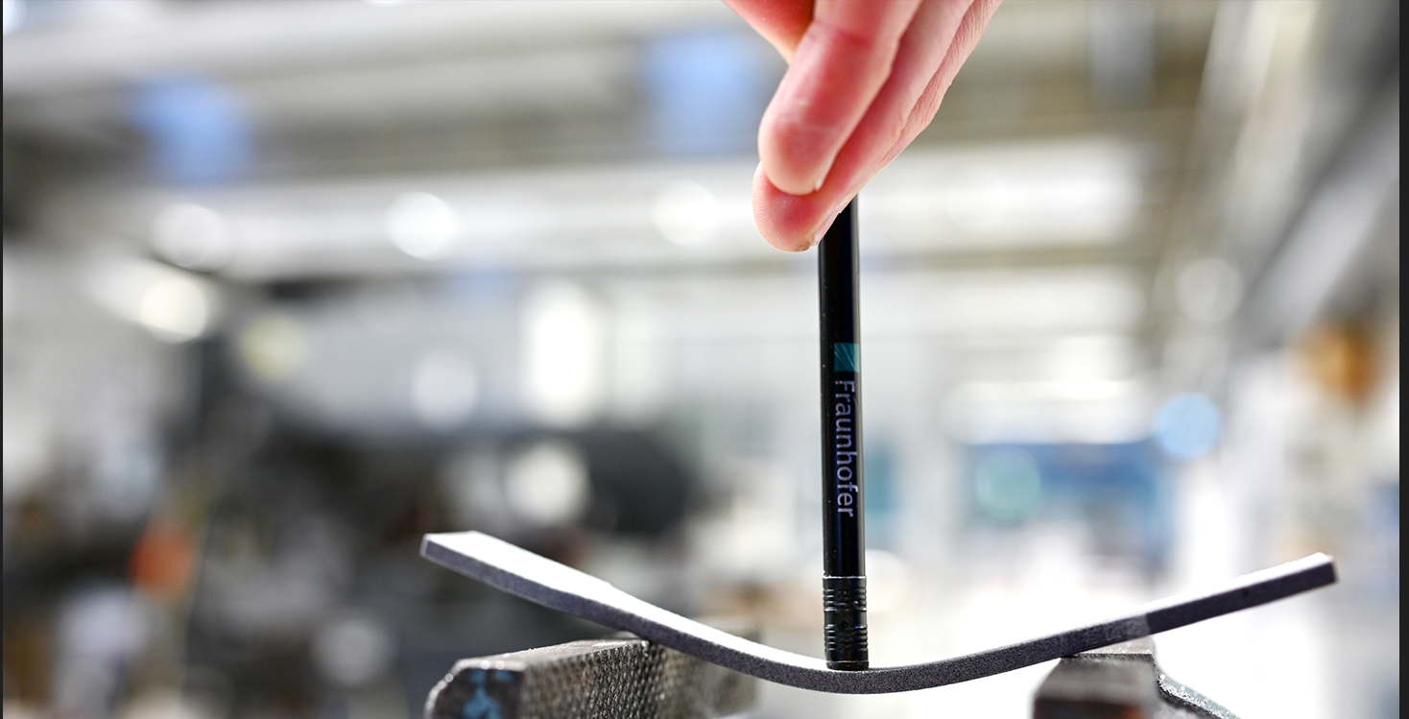
Bild 1: Test specimen manufactured in HSS from HDPE , impressive flexibility which could not be achieved with SLS due to thermal load

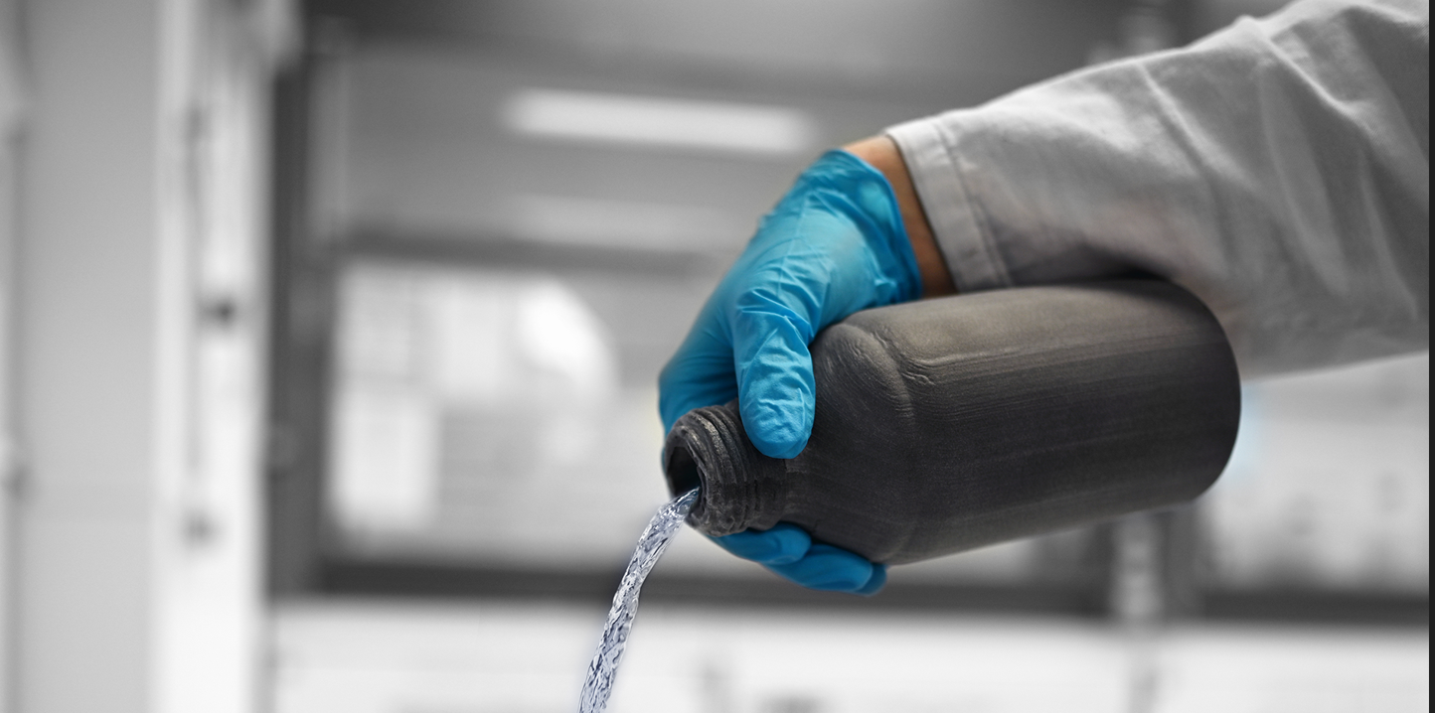
Bild 2: Bottle for chemicals made in HSS from HDPE, resistant to chemicals and greases, widely used in the packaging industry.

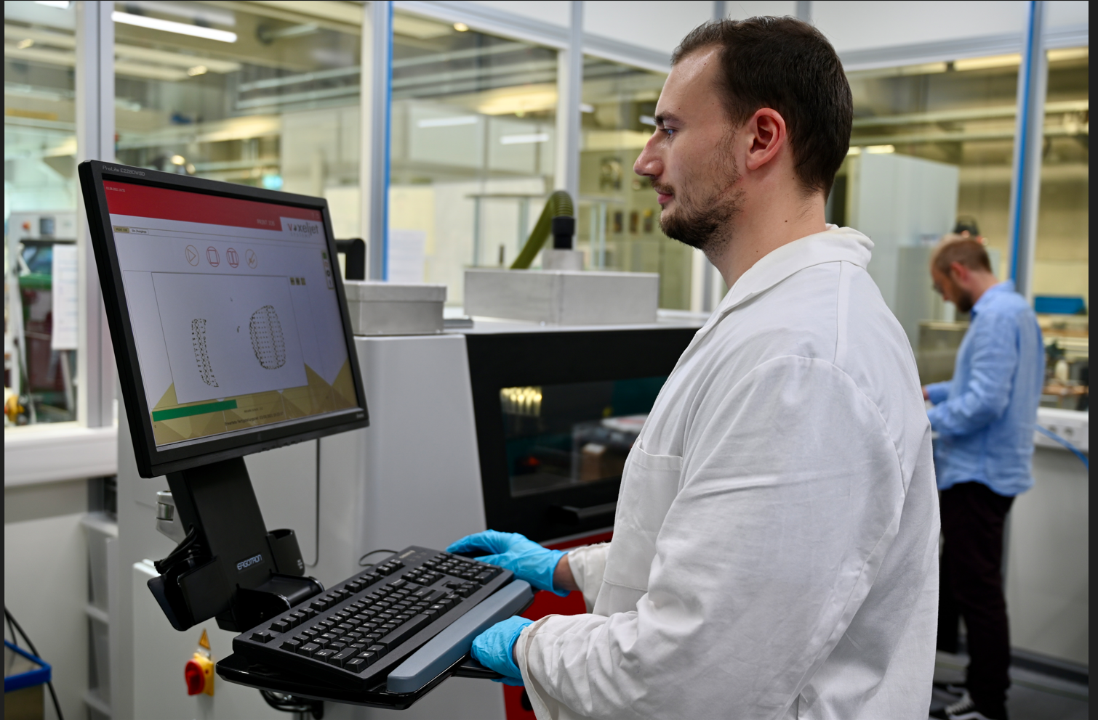
Bild 3: VX200 HSS at Fraunhofer IPA & University of Bayreuth

About voxeljet:
voxeljet is a leading provider of high-speed, large-format 3D printers and on-demand parts services to industrial and commercial customers. The Company’s 3D printers employ a powder binding, additive manufacturing technology to produce parts using various material sets, which consist of particulate materials and proprietary chemical binding agents. The Company provides its 3D printers and on-demand parts services to industrial and commercial customers serving the automotive, aerospace, film and entertainment, art and architecture, engineering, and consumer product end markets.
For more information, visit our website www.voxeljet.com or follow us on YouTube, LinkedIn, Facebook and Instagram.

Company contacs:
voxeljet AG, Paul-Lenz-Straße 1a, 86316 Friedberg, Deutschland
Marketing & Communication: Frederik von Saldern, +49 821 7483 447, frederik.vonsaldern@voxeljet.de
Investor Relations: Johannes Pesch, +49 821 7483 172, johannes.pesch@voxeljet.de

Press contacts:
EPR Advisors, Maximilianstraße 50, 86150 Augsburg
Sabine Hensold, +49 821 4508 7917, sh@epr-online.de, Andrea Schneider, +49 821 4508 7918, as@epr-online.de

