PRESS RELEASE

meteocontrol highlights at booth B3.574: Smart Alarms in the VCOM Cloud and REvolution Booster Kit for fast and secure grid connection
Intersolar Europe 2022: meteocontrol presents innovative solutions for the energy transition
Augsburg/Germany, May 04, 2022. Under the motto "Think Ahead", meteocontrol GmbH will be demonstrating at its booth B3.574 at Intersolar Europe how more efficient operational management can save time, increase yields and thus drive forward the energy transition. To this end, the full-service provider for intelligent energy management will be focusing on the completely revised 'Smart Alarms' function in VCOM Cloud and the modular package solution 'REvolution Booster Kit' for very fast grid connection at its booth. Visitors will learn how meteocontrol supports its customers with holistic and professional services in every project phase of their plant portfolio in the commercial and utility segments.
Given the accelerating growth in the PV industry worldwide, the smooth operations and management (O&M) process is of key importance to plant operators. It saves time and helps increase the yield of renewable energy generation. With the help of more efficient operations management, plant operators can respond more quickly to errors. Just in time for Intersolar Europe, the world's leading trade fair for the solar industry, meteocontrol is therefore presenting the new 'Smart Alarms' function in the VCOM Cloud: the data- and component-based solution, which is based on machine learning, can be used to intelligently identify possible failures and the corresponding causes and send specific instructions for action.
Smart alarm function
The new function in VCOM Cloud scores with several special features, as Tobias Brüser, Vice President Products at meteocontrol explains: "The Smart Alarms update their status depending on the severity. As a result, there are no redundant alarms for a failure, but only a single alarm that adapts." Other features include easier failure detection at the system and inverter level, a streamlined user interface for easy configuration of alarms, and the ability to use pre-configured default alarms or create custom alarms yourself. This makes it possible to generate only the alarms that actually matter.
Connecting PV systems to the grid quicker and securely
As another highlight, meteocontrol will launch the new modular the modular package solution 'REvolution Booster Kit' at its booth. The scalable solution allows PV systems up to 1 MWp to be quickly connected to any grid operator and direct marketer in Germany. "Our goal is to drive the energy transition forward," says Rouven Lenhart, Executive Vice President Sales & Marketing at meteocontrol. "The REvolution Booster Kit simplifies planning processes, reduces workflows and interfaces, facilitates cost calculation, shortens delivery times and makes projects effortlessly scalable." The package includes a complete, standardized hardware solution as well as all the services required for planning and commissioning the power control connection. The range of functions can be flexibly expanded and adapted to any plant topology on a project-specific basis. All interfaces are modular in design, thus enabling a high degree of scalability. The package is available at a fixed price and can be delivered within two weeks after order confirmation.
Coordination of the power plant controller concept with all relevant stakeholders such as grid operators, direct marketers or EPCs is handled by meteocontrol, as is the commissioning of the PPC solution. Additional services such as metering point verification are available as required. The Power Plant Controller is certified according to the technical connection rules for medium voltage (VDE-AR-N 4110) and high voltage (VDE-AR-N 4120) valid in Germany. Depending on the bridging time requirements, different variants (DC) with battery buffer times of four or eight hours are available.
Efficient monitoring and control of energy storage systems
One of the most important tools for reliable round-the-clock supply is energy storage. meteocontrol now offers tools to monitor not only PV systems, but also the batteries. On display at the show are new battery features that will be available in the VCOM soon: new standard charts to display the charging and discharging behaviour of the system, as well as new portlets to visualize the power flow in the system and check the most important battery values at a glance.
Data intelligence for holistic energy management
"We offer our customers comprehensive and professional services in all segments from Commercial to Utility. Our goal is to support every phase of the project with the right solutions," says Dr. Stjin Stevens, CTO at meteocontrol. "Our innovative services use data intelligence to gain complete control over assets and data. In this way, we push the evolution towards holistic energy management."
meteocontrol on course for growth
At its booth, meteocontrol will also provide information on career opportunities and job offers: With its forward-looking solutions, the full-service provider for intelligent energy management continues to grow internationally and has just recently opened another location in Berlin. The People team will be available at the trade fair stand to get to know each other and for initial discussions. All current vacancies can also be found online at https://www.meteocontrol.com/en/career/job-offers.
About meteocontrol
meteocontrol is a leading global developer and supplier of independent monitoring and flexible control systems. meteocontrol currently monitors 55,000 PV plants worldwide with a total output of more than 21 GWp. The company's 40 years of experience in the solar industry, its internal development activities and its focus on the future of renewable energy are at the heart of its innovative product developments. The planning and commissioning of professional monitoring and control systems are as much part of the portfolio as yield forecasts, technical due diligences, and energy and weather data management. As a pioneer in solar grid forecasting and feed-in extrapolation, meteocontrol calculates reliable solar power forecasts for Europe's largest grid operators as well as for utilities and plant operators worldwide. Within the scope of consulting services and expert opinions, the company has so far been involved in projects with a total investment volume of more than 14 billion euros. meteocontrol GmbH is part of the APRD Investment Group (Asia Pacific Resources Development) and is headquartered in Augsburg (Germany) with numerous locations worldwide. For more information, please visit www.meteocontrol.com
Company contact:
meteocontrol GmbH, Spicherer Str. 48, 86157 Augsburg, Germany, Tel.: +49 (0)821 34 666-0, Fax: +49 (0)821 34 666-11, Marketing and Communications: Niklas Horn, +49 (0)821 34 666-97, n.horn@meteocontrol.com
Press contact:
EPR Advisors, Maximilianstrasse 50, 86150 Augsburg, Frauke Schütz, fs@epr-online.de , +49 (0)821 4508 79-16, www.epr-online.de

Picture material:

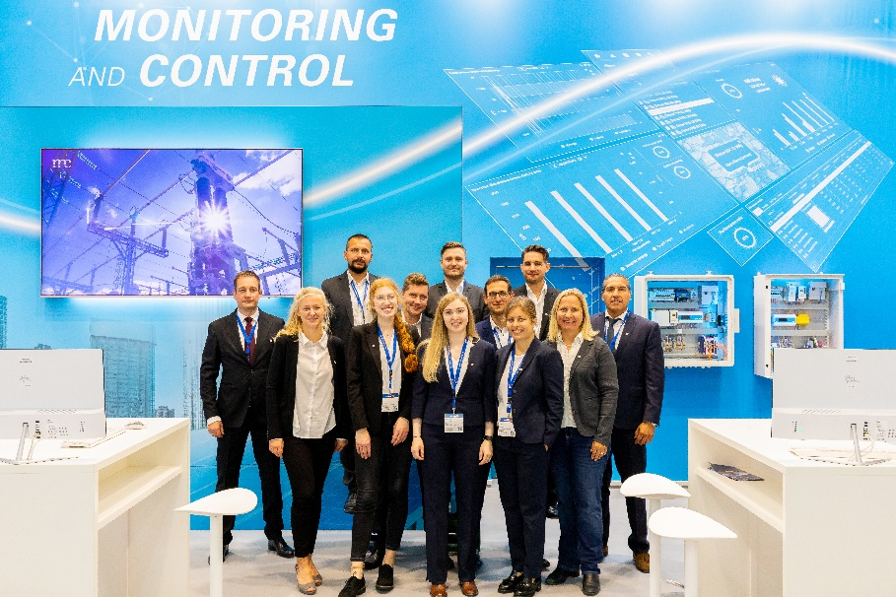

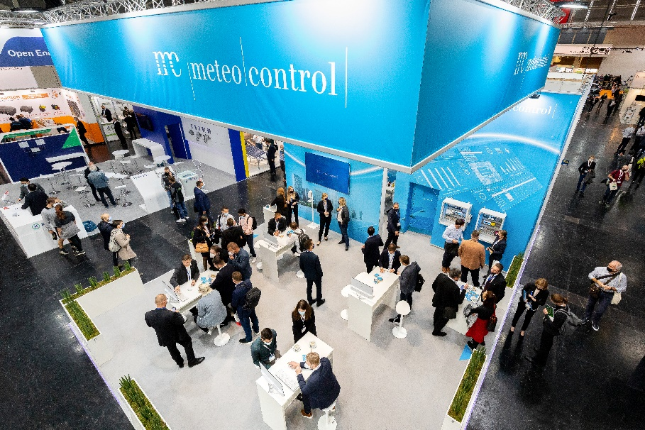
Under the motto "Think Ahead", the meteocontrol team will be presenting innovative solutions for the energy transition at Intersolar Europe at its booth B3.574. Image source: meteocontrol GmbH

