3D polymer printing on-demand: industrial 3D printer supplier launches new line of services
voxeljet now produces polymer components in the HSS process from TPU

Friedberg, 11 October 2022. voxeljet AG (NASDAQ:VJET) is expanding its portfolio of on-demand 3D printing services. Effective immediately, the company is offering on-demand parts made from thermoplastic polyurethane (TPU) using the High Speed Sintering (HSS) process. The flexible material is characterized by durable elasticity, damping properties and high impact protection. The TPU parts are used particular in the footwear industry, for padding in helmets, saddles or seats, for elastic tubes and hoses, and for sealing and packaging. The TPU material used in the HSS process was developed by voxeljet together with materials manufacturer Covestro. Customers benefit from customized polymer components in high quality at cost-effective prices.

Alongside the standard polymer PA12, TPU is one of the polymers increasingly in demand for 3D polymer printing. With its cushioning properties, the thermoplastic material has proven itself for decades in the production of shoe soles, it offers impact protection and is being used more and more across industries: in the plastics processing industry, in the automotive and consumer goods industry, in aerospace and in the engineering sector.

Different degrees of hardness through HSS technology
In the production of polymer components, voxeljet takes advantage of the special material properties of TPU in conjunction with the HSS technology: TPU can be very soft and elastic or very hard and persistent. These properties can be specifically influenced in all three dimensions using HSS technology. In High Speed Sintering, a fine layer of polymer powder is applied onto a heated build platform and the areas where the part is to be built are then inked with a heat-absorbing ink. Infrared light is used to fuse the printed areas of the polymer powder, leaving unprinted material loose. Layer by layer, the polymer is applied, printed, and irradiated until the build-up of the full jobbox and the parts within it, is complete. How soft or solid the part is depending on the volume of infrared-absorbing ink introduced. The more heavily a build area is inked, the stronger the part. By using industrial inkjet print heads, it is possible to print correspondingly different gray levels within a layer and thus realize different product properties per layer. In addition to this grayscale printing, the strength of a component can also be influenced by its geometry. Lattice structures with different wall thicknesses are used to print geometries that can be adapted to individual load profiles in order to save additional material.

Durable elasticity at attractive on-demand prices
"The HSS technology in combination with the TPU material allows us to provide an inherently hard, highly stressable part with soft properties. This opens up completely new and highly individual application possibilities of 3D printing for plastic parts," says Tobias Grün, Global Product Manager at voxeljet. TPU components produced with the HSS printing process have particularly long-lasting permanent elasticity and excellent rebound properties compared to other TPU 3D printing processes. The successfully passed Cytotoxicity test also confirms that there is no damage to cells and tissue when the material comes into contact with the skin. In addition, no discoloration of the components occurs. "With the HSS process, we can produce individualized polymer parts on-demand at high quality and speed at comparatively low cost. High Speed Sintering is an economical, efficient and resource-saving solution due to the use of large-format print heads. The technology offers enormous potential for future-oriented products," says Tobias Grün.

Partnership with materials manufacturer Covestro
The TPU qualified for the HSS technology was co-developed by voxeljet and materials manufacturer Covestro. "The close cooperation between material and machine manufacturers enabled us to bundle our joint know-how and thus coordinate and optimize the part quality as well as the 3D printing process," says Tobias Green. With the collaboration, the two companies aim to develop integrated material and process solutions for the economical additive high-volume production of polymer components.

voxeljet at formnext 2022
From November 15th to 18th, 2022, voxeljet will present its latest 3D printing solutions at formnext in Frankfurt a.M., the international trade fair for additive manufacturing technologies, at booth E11 in hall 12.1. On the first day of the trade fair, November 15th, 2022, voxeljet will hold a press conference at its stand from 12:30 to 13:00. The company cordially invites all interested parties to attend.

Bildmaterial
Image Source: voxeljet AG

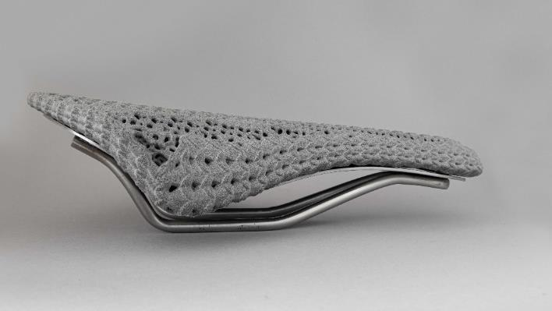
Image 1:
voxeljet AG is now printing 3D on-demand components in the HSS process from thermoplastic polyurethane (TPU).

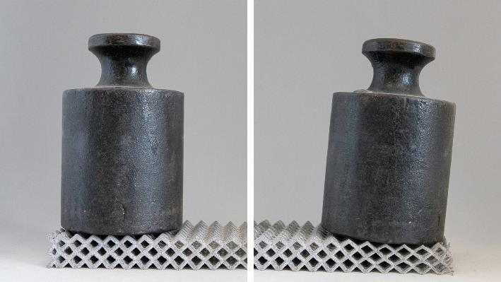
Image 2:
TPU can be very soft and elastic or very hard and durable.

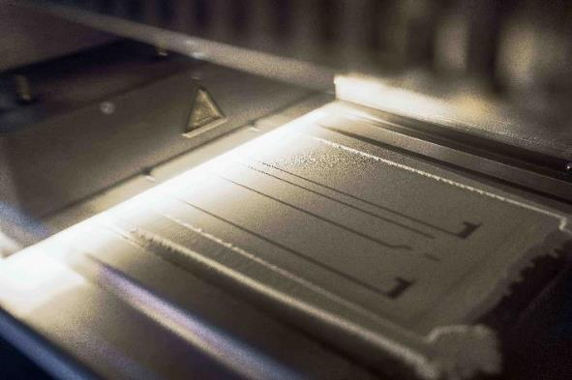
Image 3:
In the production of 3D polymer components, voxeljet takes advantage of the special material properties of TPU in combination with the HSS process.

About voxeljet:
voxeljet is a leading provider of high-speed, large-format 3D printers and on-demand parts services to industrial and commercial customers. The Company’s 3D printers employ a powder binding, additive manufacturing technology to produce parts using various material sets, which consist of particulate materials and proprietary chemical binding agents. The Company provides its 3D printers and on-demand parts services to industrial and commercial customers serving the automotive, aerospace, film and entertainment, art and architecture, engineering, and consumer product end markets.
For more information, visit our website www.voxeljet.com or follow us on YouTube, LinkedIn, Facebook and Instagram.

Company contacts:
voxeljet AG, Paul-Lenz-Straße 1a, 86316 Friedberg, Deutschland
Marketing & Communication: Frederik von Saldern, +49 821 7483 447, frederik.vonsaldern@voxeljet.de
Investor Relations: Johannes Pesch, +49 821 7483 172, johannes.pesch@voxeljet.de

Press contacts:
EPR Advisors, Maximilianstraße 50, 86150 Augsburg
Sabine Hensold, +49 821 4508 7917, sh@epr-online.de, Andrea Schneider, +49 821 4508 7918, as@epr-online.de

