Colombian utility monitors entire PV plant portfolio in Colombia and Central America with meteocontrol's VCOM Cloud solution

Monitoring of photovoltaic systems: Celsia S.A. opts for meteocontrol

Augsburg/Medellín (Colombia), 10.03.2022 - With immediate effect, meteocontrol GmbH and Celsia S.A. are entering into a cooperation with Colombia and the whole of Central America: In future, the Colombian energy supply company will monitor its entire portfolio of photovoltaic plants with meteocontrol's VCOM Cloud system. The system also centralizes and facilitates control, maintenance and repair tasks. The partnership is part of meteocontrol's internationalization strategy. With this, the leading provider of independent PV monitoring and control systems further strengthens its market presence in the dynamic Latin American market.

Celsia is an energy company of the Argos Group and operates an extensive renewable energy generation network with a total capacity of approximately 1,400 MW. This enables the company to supply clean electricity to more than 1.2 million consumers in Colombia, Panama, Costa Rica and Honduras. Celsia bundles the operational management of its production facilities and distribution networks in its NOVA control center in Yumbo, Valle del Cauca. Now the company has decided to unify the monitoring of its photovoltaic plants on a single platform. This will replace the different systems used so far.

All-in-one monitoring, power control and maintenance
The VCOM Cloud from meteocontrol is a state-of-the-art software solution for professional monitoring of photovoltaic systems. With its comprehensive functionality, high precision and flexibility, VCOM is a future-proof system for managing large commercial, industrial and municipal plant portfolios. The VCOM solution combines comprehensive monitoring functions with digitalized operation and maintenance management and a highly reliable data hosting service. This allows the operational efficiency as well as the cost efficiency of all processes to be optimized.
"We are convinced that with VCOM Cloud from meteocontrol we have found a suitable solution that meets all our requirements. The ability to manage our photovoltaic portfolio with a single efficient and centralized tool allows us to better manage and gives us more options to identify possible new developments in production," explains Carlos Alberto Moreno, Operations Leader at Celsia.

Technical support on site
With mc Central America in El Salvador and mc Chile in Santiago de Chile, meteocontrol has its own specialists in the region. Customers thus benefit from technical support in the local language and without any time delay.

About meteocontrol
meteocontrol is a leading global developer and supplier of independent monitoring and flexible control systems for photovoltaic portfolios. meteocontrol currently monitors 55,000 PV plants worldwide with a total output of more than 21 GWp. The company's 40 years of experience in the solar industry, its internal development activities and its focus on the future of renewable energies are at the heart of its innovative product developments. The planning and commissioning of professional monitoring and control systems are just as much part of the portfolio as yield forecasts, technical due diligences and energy and weather data management. As a pioneer in solar grid forecasting and feed-in extrapolation, meteocontrol calculates reliable solar power forecasts for Europe's largest grid operators as well as for energy suppliers and plant operators worldwide. Within the scope of its consulting services and expert opinions, the company has so far been involved in projects with a total investment volume of more than 14 billion euros. meteocontrol GmbH is part of the APRD Investment Group (Asia Pacific Resources Development) and is headquartered in Augsburg (Germany) with numerous locations worldwide. For further information, please visit www.meteocontrol.com

Company contact:
meteocontrol GmbH, Spicherer Str. 48, 86157 Augsburg, Tel.: +49 (0)821 34 666-0, Fax: +49 (0)821 34 666-11, Marketing and Communications: Niklas Horn, +49 (0)821 34 666-97, n.horn@meteocontrol.com

Press contact:
epr - elsaesser public relations, Maximilianstraße 50, 86150 Augsburg, Frauke Schütz, fs@epr-online.de, +49 (0)821 4508 79-16, www.epr-online.de

Picture material:

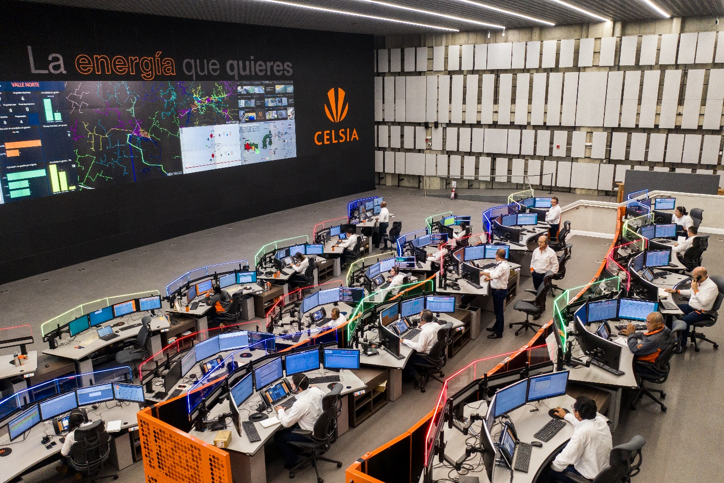

Celsia bundles the operational management of its production plants and distribution networks in the company's own NOVA control center in Yumbo, Valle del Cauca, and relies on meteocontrol's VCOM Cloud to monitor its PV plants. Image source: Celsia

