Global cooperation: ecoligo relies on meteocontrol's blue’Log X-Series for PV monitoring

meteocontrol and ecoligo complete their first PV project in Vietnam

Augsburg/Germany, August 20th, 2020 – meteocontrol GmbH, the photovoltaic monitoring specialist, and ecoligo GmbH, a PV project developer for companies in developing and emerging countries, are cooperating on a global scale: following joint projects in Africa and South America, for the first time the cooperation partners have connected a solar system to the grid in South-east Asia. meteocontrol installed its blue’Log X-Series monitoring and control system to monitor the 994 kWp roof system in southern Vietnam.

The photovoltaic system completed by ecoligo and meteocontrol has an output of 994 kilowatts peak (kWp) and is located on the roof of Dong Nam Viet Packaging in Ben Cat Town near Ho Chi Minh City. The packaging company, which is certified to ISO standards, wishes to switch to a clean energy supply. The solar system on the company’s existing building is now connected to the grid. A second system is to be installed on the company’s second production plant that is currently under construction.

Solar energy for economic growth

ecoligo is able to take on these projects in developing and emerging countries through crowdfunding by private investors in Germany. Companies, such as Dong Nam Viet Packaging, lack the financing options for the installation of a solar system. However, high energy costs, mostly from fossil fuels, prevent sustainable growth and thus slow down the entire economy in the region. ecoligo offers companies a fully funded "solar-as-a-service" solution: without having to bear the high up-front costs, this solar energy can be used at a monthly fee, which is low compared to power from the national grid. At the end of the contract, the company owns the PV system and only has to pay for maintenance. The projects are financed through the crowdinvesting platform ecoligo.investments.

blue’Log X-Series for maximum power yield

ecoligo works closely with local partners on the development, installation and maintenance of the PV projects. When it comes to monitoring and control, the project developer relies on meteocontrol, as it has already done so in Africa and South America: With its blue’Log X-Series, the Augsburg-based PV service provider supplies a made-to-measure solution for control of the power plant. Remote control enables customers to achieve maximum power yield and ecoligo can respond quickly and efficiently to error messages.

"We are pleased to have meteocontrol on board as a reliable partner for monitoring on this PV project as well. The PV market in Vietnam is currently booming and we have already secured further projects. The conditions are attractive to our crowdinvestors, also thanks to the transparency that meteocontrol monitoring provides," explains Martin Baart, CEO of ecoligo.

Rouven Lenhart, Managing Director of meteocontrol AMEA DMCC, adds: "As a partner to ecoligo, we can tap into this exciting market and drive forward the internationalisation of our operations. What's more, we help to strengthen the local economy, at the same time as contributing to climate protection. Emerging economies will grow more strongly than developed economies in the near future. If they continue to use traditional fuel sources, it will lead to even higher CO₂ emissions.”

About ecoligo
ecoligo provides a fully financed solar-as-a-service solution for businesses in emerging markets. With a complete digital platform for financing and delivering solar projects, ecoligo removes the barriers that prevent such projects from being realised. Supplying businesses with affordable electricity enables them to grow and boost the local economy. The solar projects are financed through the crowdinvesting platform www.ecoligo.investments, offering fixed and attractive returns to private investors. At the same time CO₂ emissions are reduced and the economic development of these countries is supported. In this way ecoligo effectively promotes public participation in the global energy transition: www.ecoligo.investments

About meteocontrol
meteocontrol is the leading global provider of independent solar monitoring and control systems and currently monitors more than 48,000 PV systems with a total power output of over 16 GWp. For more than 40 years, meteocontrol has developed monitoring software and hardware for solar PV systems. They offer planning and commissioning of monitoring and control systems, as well as yield forecasts, technical due diligence, and energy and weather data analytics. As part of its consulting services and reports, the company has been involved in projects with a total investment of more than 14 billion euros. meteocontrol is a member of APRD Investment Group (Asia Pacific Resources Development) and is represented worldwide with its headquarters in Augsburg, Germany and numerous locations. http://www.meteocontrol.com

Company contact information:
meteocontrol GmbH, Spicherer Str. 48, D86157 Augsburg, Tel.: +49 (0)821 34 666-0, Fax: +49 (0)821 34 666-11, Marketing and Communication: Niklas Horn, +49 (0)821 34 666-97, n.horn@meteocontrol.com

Press contact:
epr – elsaesser public relations, Maximilianstraße 50, 86150 Augsburg, Andrea Schneider, as@epr-online.de, +49 (0)821 4508 79-18, www.epr-online.de

Visual material:

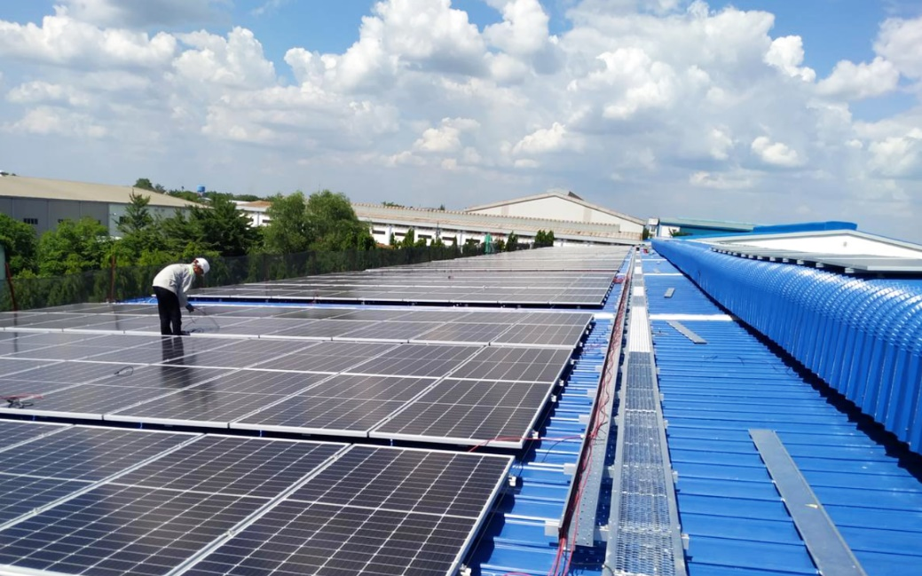

meteocontrol GmbH is supplying the blue’Log X-Series monitoring and control system for the 994 kWp solar system in Vietnam installed by ecoligo invest GmbH. (Photo source: ©Vu Phong)

