blue’Log XC certified to RD 244/2019: meteocontrol controller meets the most stringent requirements for PV self-consumption systems in Spain

Reliably connect to the Spanish power system with blue’Log XC

Augsburg, May 05, 2020 – meteocontrol GmbH has successfully obtained certification for its blue’Log XC controller for PV self-consumption on the Spanish power grid. The controller meets all requirements according to the Royal Decree (RD) 244/2019. This guarantees grid connection approval to the power system for operators of photovoltaic systems with zero feed-in. The blue’Log XC has already been extensively installed by the company's Spanish cooperation partner SolarProfit.

The independent Certification Entity for Renewable Energies, S.L. (CERE), which is accredited for ISO/IEC 17025, has confirmed: the blue’Log XC controller complies with all the requirements to enable PV self-consumption systems to be legally connected to the Spanish power system. Following measurements in five demanding tests, the blue’Log XC has been certified in accordance with Real Decreto 244/2019. This certification provides operators of systems in Spain with certainty about grid integration combined with excellent energy efficiency. Control with blue’Log XC also represents a standardised solution with which operators of zero feed-in solutions can meet all the requirements easily and quickly by parameterisation.

“Internationally, the decree currently places the most exacting technical requirements on self-consumption systems. We are proud to have successfully obtained certification. It confirms our role as a pioneer and underlines the fact that the blue’Log XC enables us to meet the most diverse grid connection requirements,” explains Martin Schneider, Managing Director of meteocontrol, continuing: “In line with the stipulations of the Real Decreto 244/2019, the blue’Log XC is certified together with one inverter series. In future, we plan to achieve certification with other inverter manufacturers.”

SolarProfit relies on blue’Log XC

meteocontrol has always sought long-term cooperative partnerships with local companies to market its solutions. SolarProfit represents such a partner for meteocontrol in Spain and has already successfully completed over 30 PV projects with the blue’Log XC. The company, which has its headquarters to the north-east of Barcelona, has specialised in the planning and management of PV self-consumption systems for private households and in the “commercial and industrial” segment. SolarProfit needs a user-friendly monitoring and control solution in order to make commissioning as efficient and reliable as possible for its many customers and high number of PV systems.

“Certification in accordance with the Real Decreto 244/2019 is a major challenge for the Spanish PV market. Without this certification we are unable to connect PV systems to the power system without discharging excess energy into the distribution network. With meteocontrol's blue’Log XC we can now install our projects safely and reliably,” explains Óscar Gómez, Managing Director of SolarProfit.

Following numerous revisions to the legislation in recent years, the Spanish Royal Decree RD 244/2019 now clearly defines the administrative, technical and economic conditions regulating the self-consumption of electrical energy. The provisions enable self-consumption in communities and industrial zones and reduce the administrative bureaucracy, particularly for small self-consumers. They also provide for a simplified self-consumption mechanism for the feed-in of excess solar power. The Spanish government hopes that this will introduce greater dynamism into the renewable energy sector and help to protect the climate.

About meteocontrol
meteocontrol is the leading global provider of independent solar monitoring and control systems and currently monitors more than 48,000 PV systems with a total power output of over 16 GWp. For more than 40 years, meteocontrol has developed monitoring software and hardware for solar PV systems. They offer planning and commissioning of monitoring and control systems, as well as yield forecasts, technical due diligence, and energy and weather data analytics. As part of its consulting services and reports, the company has been involved in projects with a total investment of more than 14 billion euros. meteocontrol is a member of APRD Investment Group (Asia Pacific Resources Development) and is represented worldwide with its headquarters in Augsburg, Germany and numerous locations. http://www.meteocontrol.com

Company contact information:
meteocontrol GmbH, Spicherer Str. 48, D86157 Augsburg, Tel.: +49 (0)821 34 666-0, Fax: +49 (0)821 34 666-11, Marketing and Communication: Niklas Horn, +49 (0)821 34 666-97, n.horn@meteocontrol.com

Press contact:
epr – elsaesser public relations, Maximilianstraße 50, 86150 Augsburg, Andrea Schneider, as@epr-online.de, +49 (0)821 4508 79-18, www.epr-online.de

Visual material:

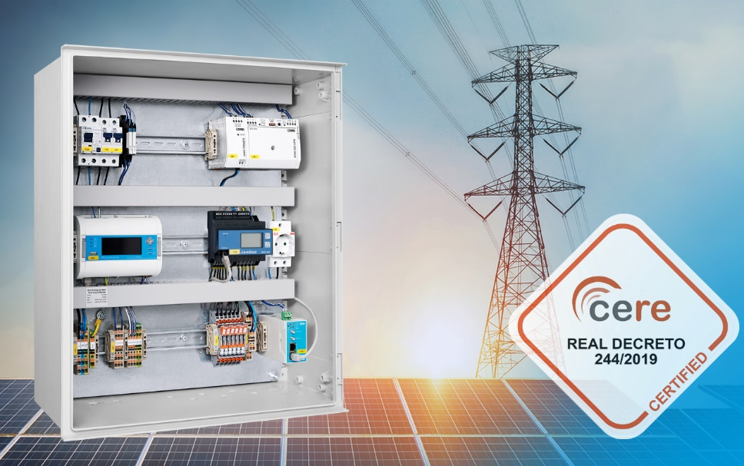

meteocontrol's blue’Log XC is certified for the Spanish market according to the Real Decreto (RD) 244/2019. PV self-consumption systems can now be legally connected to the Spanish power system.

